E-Commerce Customer Churn Analysis
Data Cleaning:
Handling Missing Values and Outliers:
➢ Impute mean for the following columns, and round off to the nearest integer if required: WarehouseToHome, HourSpendOnApp, OrderAmountHikeFromlastYear, DaySinceLastOrder.
UPDATE customer_churn SET WarehouseToHome= (
SELECT Average_val FROM (
SELECT round (avg (WarehouseToHome)) as Average_val FROM customer_churn WHERE WarehouseToHome is NOT NULL) as tmp)
WHERE WarehouseToHome IS NULL;
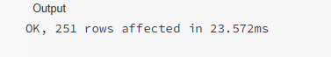
UPDATE customer_churn SET HourSpendOnApp= (
SELECT Avg_val FROM (
SELECT round (avg (HourSpendOnApp)) as Avg_val FROM customer_churn WHERE HourSpendOnApp is NOT NULL) as tmp)
WHERE HourSpendOnApp IS NULL;
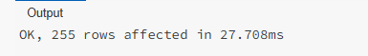
UPDATE customer_churn SET OrderAmountHikeFromlastYear=
(select avg_val FROM (
SELECT ROUND (avg (OrderAmountHikeFromlastYear)) as avg_val FROM customer_churn
WHERE OrderAmountHikeFromlastYear IS NOT NULL) as tmp
) WHERE OrderAmountHikeFromlastYear IS NULL;
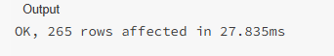
UPDATE customer_churn SET DaySinceLastOrder=
(select avg_val from (
select ROUND (avg (DaySinceLastOrder)) AS avg_val FROM customer_churn
WHERE DaySinceLastOrder IS NOT NULL) as tmp
) WHERE DaySinceLastOrder IS NULL;
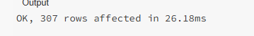
➢ Impute mode for the following columns: Tenure, CouponUsed, OrderCount.
UPDATE customer_churn SET tenure= (
SELECT mode_val FROM (
SELECT tenure as mode_val FROM customer_churn
WHERE Tenure is NOT NULL GROUP BY Tenure
ORDER BY COUNT (*) DESC
limit 1 ) as tmp
) WHERE tenure is NULL;
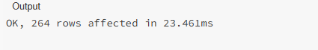
UPDATE customer_churn SET CouponUsed= (
SELECT mode_val FROM (
SELECT CouponUsed as mode_val FROM customer_churn
WHERE CouponUsed is NOT NULL GROUP BY CouponUsed
ORDER BY count (*) DESC
limit 1 ) AS tmp
) Where CouponUsed is null;
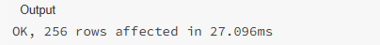
UPDATE customer_churn SET OrderCount= (
SELECT mode_val FROM (
SELECT OrderCount as mode_val FROM customer_churn
WHERE OrderCount is NOT NULL
GROUP BY OrderCount
ORDER BY COUNT (*) DESC
LIMIT 1 ) AS tmp
) WHERE OrderCount is NULL;
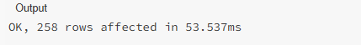
➢ Handle outliers in the 'WarehouseToHome' column by deleting rows where the values are greater than 100.
DELETE FROM customer_churn WHERE WarehouseToHome>100;
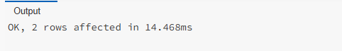
Dealing with Inconsistencies:
➢ Replace occurrences of “Phone” in the 'PreferredLoginDevice' column and “Mobile” in the 'PreferedOrderCat' column with “Mobile Phone” to ensure uniformity.
UPDATE customer_churn SET PreferredLoginDevice="Mobile Phone"
WHERE PreferredLoginDevice='Phone';
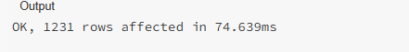
UPDATE customer_churn SET PreferedOrderCat="Mobile Phone"
WHERE PreferedOrderCat='Mobile';
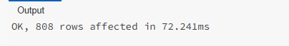
➢ Standardize payment mode values: Replace "COD" with "Cash on Delivery" and "CC" with "Credit Card" in the PreferredPaymentMode column.
UPDATE customer_churn SET PreferredPaymentMode="Cash on Delivery"
WHERE PreferredPaymentMode='COD';
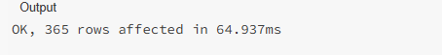
UPDATE customer_churn SET PreferredPaymentMode="Credit Card"
WHERE PreferredPaymentMode='CC';
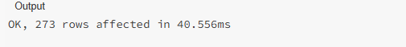
Data Transformation: (3 marks)
Column Renaming:
➢ Rename the column "PreferedOrderCat" to "PreferredOrderCat".
ALTER TABLE customer_churn RENAME COLUMN PreferedOrderCat TO PreferredOrderCat;
➢ Rename the column "HourSpendOnApp" to "HoursSpentOnApp".
ALTER TABLE customer_churn RENAME COLUMN HourSpendOnApp TO HoursSpentOnApp;
DESCRIBE customer_churn;
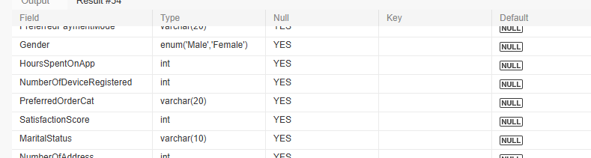

Creating New Columns:
➢ Create a new column named ‘ComplaintReceived’ with values "Yes" if the corresponding value in the ‘Complain’ is 1, and "No" otherwise.
ALTER TABLE customer_churn ADD COLUMN ComplaintReceived VARCHAR (3);
UPDATE customer_churn SET ComplaintReceived=
CASE
WHEN Complain=1 THEN 'Yes'
ELSE 'No'
END;
➢ Create a new column named 'ChurnStatus'. Set its value to “Churned” if the corresponding value in the 'Churn' column is 1, else assign “Active”.
ALTER TABLE customer_churn ADD COLUMN ChurnStatus VARCHAR (10);
UPDATE customer_churn SET ChurnStatus=
CASE
WHEN Churn=1 THEN 'Churned'
ELSE 'Active'
END;

SELECT Complain, ComplaintReceived, Churn, ChurnStatus FROM customer_churn LIMIT 50;
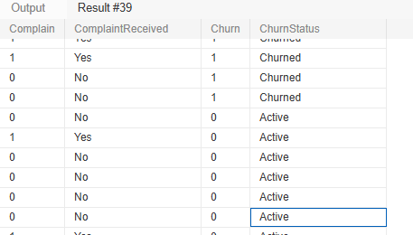

Column Dropping:
➢ Drop the columns "Churn" and "Complain" from the table.
ALTER TABLE customer_churn DROP COLUMN Churn , DROP COLUMN Complain;
Data Exploration and Analysis: (17 marks)
➢ Retrieve the count of churned and active customers from the dataset.
SELECT ChurnStatus, count (*) as Count_Of_Customers FROM customer_churn
GROUP by ChurnStatus;
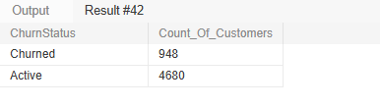
➢ Display the average tenure and total cashback amount of customers who churned.
SELECT ROUND (avg(tenure)) as Avg_Tenure,
SUM (cashbackAmount) as total_cashback_Amount
from customer_churn
WHERE churnstatus='Churned';
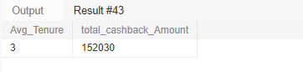
➢ Determine the percentage of churned customers who complained.
SELECT ROUND (COUNT (
case when complaintReceived='Yes’ THEN 1 end) *100/ COUNT (*),2
) AS ComplaintPercentage
FROM customer_churn
WHERE churnstatus='Churned';
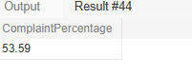
➢ Identify the city tier with the highest number of churned customers whose preferred order category is Laptop & Accessory.
SELECT cityTier, count (*) As Customer_Count
FROM customer_churn
WHERE churnstatus='Churned' AND preferredOrderCat='Laptop & Accessory'
GROUP BY cityTier
ORDER BY count (*) DESC
LIMIT 1;
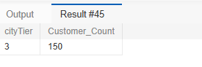
➢ Identify the most preferred payment mode among active customers.
SELECT PreferredPaymentMode, COUNT (*) AS No_Of_Customers
FROM customer_churn
WHERE churnstatus='Active'
GROUP by PreferredPaymentMode
ORDER BY No_Of_Customers DESC
limit 1;
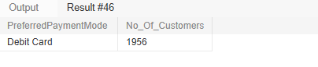
➢ Calculate the total order amount hike from last year for customers who are single and prefer mobile phones for ordering.
SELECT SUM(OrderAmountHikeFromlastYear) AS Total_OrderAmount_Hike
FROM customer_churn
WHERE maritalStatus ='Single' AND preferredOrderCat='Mobile Phone';
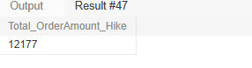
➢ Find the average number of devices registered among customers who used UPI as their preferred payment mode.
SELECT ROUND (avg (NumberOfDeviceRegistered),2) AS Avg_Registered_Devices
FROM customer_churn
WHERE PreferredPaymentMode='UPI';
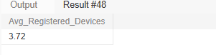
➢ Determine the city tier with the highest number of customers.
SELECT cityTier, Count (*) AS Customer_Count
FROM customer_churn
GROUP BY cityTier
ORDER BY Customer_Count DESC
limit 1;
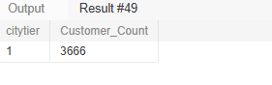
➢ Identify the gender that utilized the highest number of coupons.
SELECT gender, sum (CouponUsed) as Highest_No_Of_Coupons
FROM customer_churn
GROUP BY gender
ORDER BY Highest_No_Of_Coupons DESC
LIMIT 1;
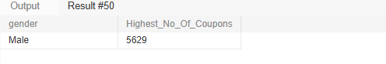
➢ List the number of customers and the maximum hours spent on the app in each preferred order category.
SELECT preferredorderCat, count(*) AS No_Of_Customers, MAX(HoursSpentOnApp) AS Maximum_hours_Spent
FROM customer_churn
GROUP BY preferredorderCat;
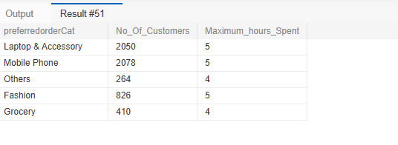
➢ Calculate the total order count for customers who prefer using credit cards and have the maximum satisfaction score.
SELECT SUM(OrderCount) AS Total_OrderCount
FROM customer_churn
WHERE preferredpaymentmode='Credit Card'
AND SatisfactionScore= (select max (SatisfactionScore) FROM customer_churn);
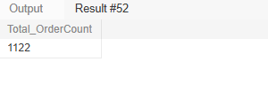
➢ What is the average satisfaction score of customers who have complained?
SELECT ROUND (avg (SatisfactionScore),2) AS Avg_Satisfaction_Score
FROM customer_churn
WHERE complaintReceived ='Yes';
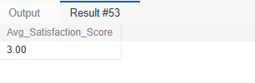
➢ List the preferred order category among customers who used more than 5 coupons.
SELECT DISTINCT preferredorderCat FROM customer_churn WHERE CouponUsed>5 ;
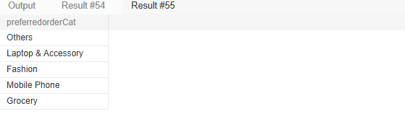
➢ List the top 3 preferred order categories with the highest average cashback amount.
SELECT preferredorderCat, round (avg (CashbackAmount),2) AS Avg_Cashback_Amount
FROM customer_churn
GROUP BY preferredorderCat
ORDER BY Avg_Cashback_Amount DESC
LIMIT 3;
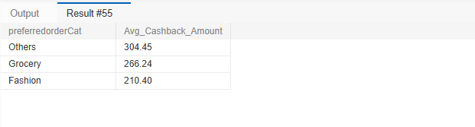
➢ Find the preferred payment modes of customers whose average tenure is 10 months and have placed more than 500 orders.
SELECT PreferredPaymentMode, round(avg(tenure)) as AverageTenure, SUM (ordercount) as TotalOrders
FROM customer_churn
GROUP BY PreferredPaymentMode
HAVING AverageTenure=10 AND TotalOrders>500;
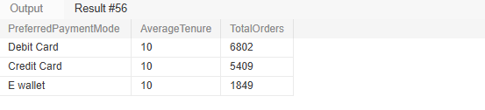
➢ Categorize customers based on their distance from the warehouse to home such as 'Very Close Distance' for distances <=5km, 'Close Distance' for <=10km, 'Moderate Distance' for <=15km, and 'Far Distance' for >15km. Then, display the churn status breakdown for each distance category.
SELECT
CASE WHEN WarehouseToHome <=5 THEN 'Very Close Distance'
When WarehouseToHome <=10 THEN 'Close Distance'
WHEN WarehouseToHome <=15 THEN 'Moderate Distance'
ELSE 'Far Distance'
END AS Distance_category, churnStatus, Count (*) as No_Of_Customers
FROM customer_churn
GROUP BY Distance_category, churnStatus
ORDER BY Distance_category;
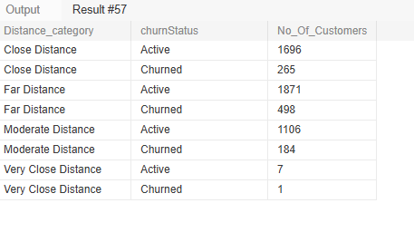
➢ List the customer’s order details who are married, live in City Tier-1, and their order counts are more than the average number of orders placed by all customers.
SELECT * FROM customer_churn
WHERE MaritalStatus ='married'
AND CityTier=1
AND OrderCount > (select avg(ordercount)from customer_churn);
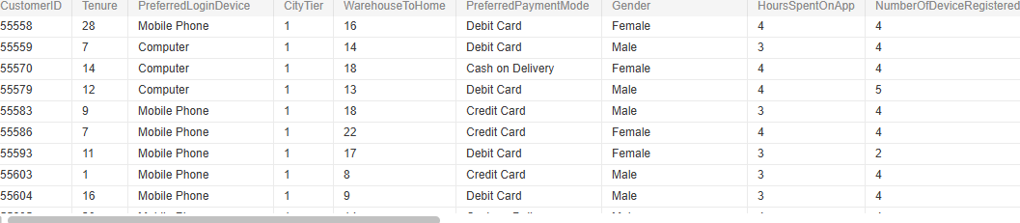
➢ a) Create a ‘customer_returns’ table in the ‘ecomm’ database and insert the following data:
ReturnID | CustomerID | ReturnDate | RefundAmount
1001 | 50022 | 2023-01-01 | 2130
1002 | 50316 | 2023-01-23 | 2000
1003 | 51099 | 2023-02-14 | 2290
1004 | 52321 | 2023-03-08 | 2510
1005 | 52928 | 2023-03-20 | 3000
1006 | 53749 | 2023-04-17 | 1740
1007 | 54206 | 2023-04-21 | 3250
1008 | 54838 | 2023-04-30 | 1990
CREATE TABLE customer_returns (
ReturnID INT PRIMARY KEY,
CustomerID INT,
ReturnDate DATE,
RefundAmount DECIMAL (10,2)
);
DESCRIBE customer_returns;
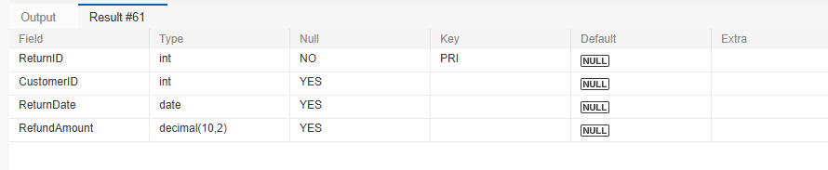
INSERT INTO customer_returns VALUES (1001,50022,'2023-01-01',2130),
(1002,50316,'2023-01-23',2000),
(1003,51099,'2023-02-14',2290),
(1004,52321,'2023-03-08',2510),
(1005,52928,'2023-03-20',3000),
(1006,53749,'2023-04-17',1740),
(1007,54206,'2023-04-21',3250),
(1008,54838,'2023-04-30',1990);
SELECT * FROM customer_returns;
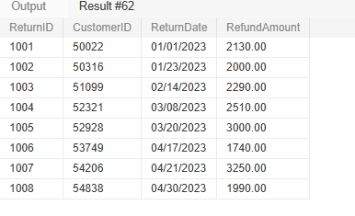
b) Display the return details along with the customer details of those who have churned and have made complaints.
SELECT Ret.*, churn.* FROM customer_returns Ret
JOIN customer_churn churn
ON ret.customerid = churn.customerid
WHERE churn.ChurnStatus='Churned' AND churn.complaintReceived ='Yes';


